WatchNext Power BI starter guide
Oct 29, 2026 · @Md Asif Iqbal
In about an hour, you will turn your WatchNext history into your own Power BI dashboard, with no coding knowledge needed. You copy and paste every piece of code from this guide.
Your finished one-page report shows:
- four big numbers: episodes watched, movies watched, total hours, and shows watched
- a chart of how much you watched each month
- your top 10 shows
- which day of the week you watch most
- where you watch (Netflix, Stan and so on)
- a year picker that changes everything on the page
What you need
You need | Why
A Windows 10 or 11 computer | Power BI Desktop only runs on Windows. There is no Mac version.
WatchNext open on that computer | To download your three data files
About 1 hour the first time | About 2 minutes each time after that, to refresh with new data
How to use this guide: do the parts in order. Each step says exactly what to click. Words in bold are buttons or menu names you will see on screen.

Part 1: Install Power BI Desktop (10 minutes)
Power BI Desktop is Microsoft's free program for making reports. It installs from the Microsoft Store, and you do not need an account to build reports on your own computer.
- Click the Start button (the Windows logo, bottom left), type Microsoft Store and open it.
- In the Store's search box at the top, type Power BI Desktop and press Enter.
- Click Power BI Desktop (the yellow bar-chart icon, made by Microsoft Corporation).
- Click Get (or Install) and wait. It is a large download, so it can take a few minutes.
- When it finishes, click Open. Next time, find it by typing Power BI in the Start menu.
- A welcome window may ask you to sign in or to fill in your details. Close it with the X in its corner. You do not need to sign in to follow this guide.
- You now see a mostly empty white screen with a ribbon of buttons at the top. That is your blank report, called the Report view.
Good to know
- Power BI needs Windows 10 or later, and at least 2 GB of free memory (4 GB or more is better). Microsoft's install page
- The Store version updates itself every month and does not need an administrator password.
- On a Mac? There is no Mac version. Use a Windows computer, or open the CSV files in Excel instead. Excel can make simple charts from the same files.
- Work computer? Some workplaces block the Microsoft Store. If so, use your own computer for this personal project.
The ribbon at the top has tabs such as Home, Insert and Modeling. Down the left edge are three small icons that switch views: Report (the page you design), Table (see your data as rows) and Model (how your tables connect). You will use all three.

Part 2: Export your data from WatchNext (5 minutes)
You download three CSV files and put them, with short fixed names, in one folder: C:\WatchNext Data. The fixed names are what let you refresh the report later in one click.
Download the files
- Open WatchNext in your web browser on the same Windows computer.
- Tap Settings in the bottom bar.
- Scroll down to the card called Export for Power BI.
- Click Episodes, then Shows, then Movies. Each click saves one file to your Downloads folder.
File you get | One row for each | Example name
Episodes | episode you watched | watchnext-episodes-2026-10-29.csv
Shows | show in your library or watchlist | watchnext-shows-2026-10-29.csv
Movies | movie you watched or plan to watch | watchnext-movies-2026-10-29.csv
Make the folder
- Open File Explorer (the yellow folder icon on the taskbar).
- Click This PC on the left, then double-click Local Disk (C:).
- Right-click an empty space, choose New, then Folder, and name it exactly WatchNext Data.
Move and rename the files
- In File Explorer, open Downloads and find the three files.
- First, show file endings so you can rename safely: click View, then Show, then tick File name extensions. (On Windows 10: the View tab, then tick File name extensions.)
- Drag the three files into C:\WatchNext Data.
- Rename each one (right-click it, then Rename) to remove the date:
  - watchnext-episodes.csv
  - watchnext-shows.csv
  - watchnext-movies.csv
Your folder should now hold exactly these three files. Do not open them in Excel and save them, because Excel can change the dates and break the next steps. Opening them just to look, then closing without saving, is fine.
Privacy: the files include your episode notes and reactions, but never your TMDB key or any passwords.

Part 3: Load the three files into Power BI (15 minutes)
You paste one block of ready-made code per file. The code reads the file, sets each column's type (date, number, yes/no), fills in missing run times, and turns platform codes like “prime” into “Prime Video”.
Load the Episodes file
- In Power BI, on the Home tab, click the small arrow under Get data, then click Blank query. A new window opens: the Power Query Editor.
- In that window, on its Home tab, click Advanced Editor.
- Select everything in the white box (press Ctrl+A), delete it, then paste the Episodes code below. Click Done.
- After a moment you see your episodes as rows. On the right, under Query Settings, click the name Query1 and change it to Episodes. Press Enter.
let
Folder = "C:\WatchNext Data\",
Source = Csv.Document(File.Contents(Folder & "watchnext-episodes.csv"), [Delimiter = ",", Encoding = 65001, QuoteStyle = QuoteStyle.Csv]),
Headers = Table.PromoteHeaders(Source, [PromoteAllScalars = true]),
Blanks = Table.ReplaceValue(Headers, "", null, Replacer.ReplaceValue, Table.ColumnNames(Headers)),
Types = Table.TransformColumnTypes(Blanks, {
{"show_id", type text}, {"tmdb_id", Int64.Type}, {"show_name", type text},
{"season", Int64.Type}, {"episode", Int64.Type}, {"watched_at_utc", type text},
{"watched_date_local", type date}, {"watched_time_local", type time},
{"watch_count", Int64.Type}, {"runtime_min", Int64.Type}, {"is_bulk_import", type logical},
{"platform", type text}, {"show_status", type text}, {"in_library", type logical},
{"dropped", type logical}, {"genres", type text}, {"reaction", type text}, {"note", type text}
}, "en-US"),
Minutes = Table.AddColumn(Types, "minutes_watched", each (if [runtime_min] = null then 40 else [runtime_min]) * [watch_count], Int64.Type),
PlatformNames = [netflix = "Netflix", prime = "Prime Video", disney = "Disney+", max = "HBO Max", stan = "Stan", binge = "Binge", appletv = "Apple TV+", paramount = "Paramount+", crunchyroll = "Crunchyroll", hulu = "Hulu", iview = "ABC iview", sbs = "SBS On Demand", youtube = "YouTube", cinema = "Cinema", other = "Other"],
Platforms = Table.TransformColumns(Minutes, {{"platform", each if _ = null then "Not set" else Record.FieldOrDefault(PlatformNames, _, _), type text}})
in
Platforms
Load the Shows file
- Still in the Power Query Editor: on its Home tab, click the arrow under New Source, then Blank Query.
- Click Advanced Editor, delete everything, paste the Shows code below, and click Done.
- Rename the query from Query1 to Shows.
let
Folder = "C:\WatchNext Data\",
Source = Csv.Document(File.Contents(Folder & "watchnext-shows.csv"), [Delimiter = ",", Encoding = 65001, QuoteStyle = QuoteStyle.Csv]),
Headers = Table.PromoteHeaders(Source, [PromoteAllScalars = true]),
Blanks = Table.ReplaceValue(Headers, "", null, Replacer.ReplaceValue, Table.ColumnNames(Headers)),
Types = Table.TransformColumnTypes(Blanks, {
{"show_id", type text}, {"tmdb_id", Int64.Type}, {"name", type text},
{"in_library", type logical}, {"on_watchlist", type logical}, {"status", type text},
{"dropped", type logical}, {"dropped_at_utc", type text}, {"platform", type text},
{"rating", type number}, {"rated_at_utc", type text}, {"added_at_utc", type text},
{"tmdb_status", type text}, {"total_episodes", Int64.Type}, {"episodes_watched", Int64.Type},
{"progress_pct", Int64.Type}, {"runtime_min", Int64.Type}, {"genres", type text},
{"first_watched_at_utc", type text}, {"last_watched_at_utc", type text}, {"is_anime", type logical}
}, "en-US"),
PlatformNames = [netflix = "Netflix", prime = "Prime Video", disney = "Disney+", max = "HBO Max", stan = "Stan", binge = "Binge", appletv = "Apple TV+", paramount = "Paramount+", crunchyroll = "Crunchyroll", hulu = "Hulu", iview = "ABC iview", sbs = "SBS On Demand", youtube = "YouTube", cinema = "Cinema", other = "Other"],
Platforms = Table.TransformColumns(Types, {{"platform", each if _ = null then "Not set" else Record.FieldOrDefault(PlatformNames, _, _), type text}})
in
Platforms
Load the Movies file
- Again: New Source, Blank Query, Advanced Editor, paste the Movies code below, Done.
- Rename the query to Movies.
let
Folder = "C:\WatchNext Data\",
Source = Csv.Document(File.Contents(Folder & "watchnext-movies.csv"), [Delimiter = ",", Encoding = 65001, QuoteStyle = QuoteStyle.Csv]),
Headers = Table.PromoteHeaders(Source, [PromoteAllScalars = true]),
Blanks = Table.ReplaceValue(Headers, "", null, Replacer.ReplaceValue, Table.ColumnNames(Headers)),
Types = Table.TransformColumnTypes(Blanks, {
{"tmdb_id", Int64.Type}, {"name", type text}, {"status", type text},
{"watched_at", type text}, {"watched_date_local", type date}, {"rating", type number},
{"rated_at_utc", type text}, {"platform", type text}, {"runtime_min", Int64.Type},
{"year", Int64.Type}, {"reaction", type text}, {"note", type text}
}, "en-US"),
Minutes = Table.AddColumn(Types, "minutes_watched", each if [runtime_min] = null then 110 else [runtime_min], Int64.Type),
PlatformNames = [netflix = "Netflix", prime = "Prime Video", disney = "Disney+", max = "HBO Max", stan = "Stan", binge = "Binge", appletv = "Apple TV+", paramount = "Paramount+", crunchyroll = "Crunchyroll", hulu = "Hulu", iview = "ABC iview", sbs = "SBS On Demand", youtube = "YouTube", cinema = "Cinema", other = "Other"],
Platforms = Table.TransformColumns(Minutes, {{"platform", each if _ = null then "Not set" else Record.FieldOrDefault(PlatformNames, _, _), type text}})
in
Platforms
Finish loading
- On the left of the Power Query Editor you should see three queries: Episodes, Shows and Movies.
- Click Close & Apply (top left). Power BI loads your data. This takes a few seconds.
- Check it worked: click the Table view icon on the far left (it looks like a small grid). On the right, under Data, click each table to see its rows.
If you saved the folder somewhere other than C:\WatchNext Data, change the Folder = line at the top of each code block. Keep the backslash at the end.

Part 4: Add a calendar and connect the tables (10 minutes)
A calendar table lets one year picker control both episodes and movies. Then you draw three links, so Power BI knows which episodes belong to which show and which day.
Make the calendar
- Click the Table view icon on the far left.
- On the Home tab (called Table tools in some versions), click New table.
- A formula bar appears above the grid. Delete what is there, paste this, and press Enter:
Calendar =
ADDCOLUMNS (
CALENDARAUTO (),
"Year", FORMAT ( [Date], "yyyy" ),
"Month No", MONTH ( [Date] ),
"Month", FORMAT ( [Date], "mmm" ),
"Year Month", FORMAT ( [Date], "yyyy-mm" ),
"Weekday No", WEEKDAY ( [Date], 2 ),
"Weekday", FORMAT ( [Date], "ddd" )
)
- A Calendar table appears with one row per day, from your first watch to the end of this year.
- Make months and weekdays sort in calendar order, not A to Z:
  - Click the Month column heading. On the Column tools tab, click Sort by column and choose Month No.
  - Click the Weekday column heading. Click Sort by column and choose Weekday No.
- Optional but good practice: on the Table tools tab, click Mark as date table, choose the Date column and click OK.
Connect the tables
- Click the Model view icon on the far left (it looks like three linked boxes). You see four boxes: Calendar, Episodes, Shows and Movies.
- Power BI may already have drawn some lines between them. You want exactly the three links in the table and picture below, and no others.
- To delete a wrong line: click it, press Delete, then click Yes.
- To add a link: drag the field name from the first box and drop it onto the field in the second box. A window opens. Check it says Many to one or One to many and Single, then click Save (or OK).
Drag this field | onto this field | What it means
Calendar → Date | Episodes → watched_date_local | which day each episode was watched
Calendar → Date | Movies → watched_date_local | which day each movie was watched
Shows → show_id | Episodes → show_id | which show each episode belongs to
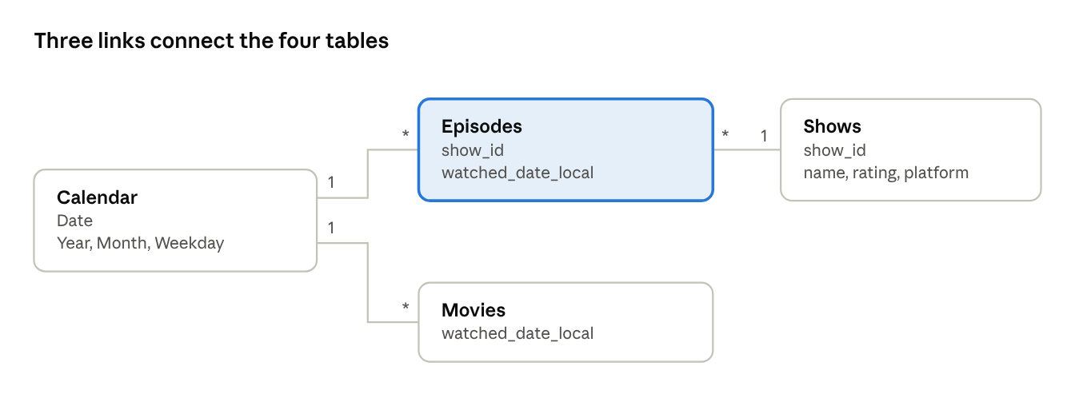
Model view when it's right · 4 tables, 3 links
In Model view, “1” marks the side with one row (one day, one show) and “*” the side with many rows (many episodes or movies).
A common mistake: Power BI sometimes links Shows and Movies through tmdb_id. That link is wrong, because shows and movies have separate ID lists. Delete it if you see it.

Part 5: Add the measures (10 minutes)
A measure is a saved calculation, such as “total episodes”. You add eight. Each one recalculates automatically when you pick a year.
How to add each measure
- Click the Report view icon on the far left (the bar-chart icon).
- On the right, in the Data pane, right-click Episodes and choose New measure.
- A formula bar appears at the top. Delete what is there, paste ONE measure from the table below, and press Enter.
- Repeat steps 2 and 3 for each measure. A small calculator icon appears next to each one under Episodes.
Measure (paste the whole line) | What it shows
Episodes Watched = SUM ( Episodes[watch_count] ) | Episodes watched, rewatches included
Movies Watched = CALCULATE ( COUNTROWS ( Movies ), Movies[status] = "watched" ) | Movies watched, watchlist movies left out
Watches = [Episodes Watched] + [Movies Watched] | Episodes and movies together
TV Hours = DIVIDE ( SUM ( Episodes[minutes_watched] ), 60 ) | Hours of TV
Movie Hours = DIVIDE ( CALCULATE ( SUM ( Movies[minutes_watched] ), Movies[status] = "watched" ), 60 ) | Hours of movies
Total Hours = ROUND ( [TV Hours] + [Movie Hours], 0 ) | All hours, rounded
Shows Watched = DISTINCTCOUNT ( Episodes[show_id] ) | How many different shows you watched
Real Episodes = CALCULATE ( [Episodes Watched], Episodes[is_bulk_import] = FALSE () ) | Episodes without bulk-imported history
Why “Real Episodes”? When you imported old history (for example from TV Time), hundreds of episodes got the same date and minute. WatchNext marks those rows as is_bulk_import. Leaving them out keeps the weekday chart honest, just like the app's Stats do.
One small difference from the app: the CSV saves each episode with its first-watch date. A rewatch counts on that first date here, while the app's Stats count it on the day you rewatched. The totals still match.

Part 6: Build the starter report (15 minutes)
You place seven visuals on one page, laid out like the picture below. Every visual is made the same way: click an empty part of the page, click a visual's icon in the Visualizations pane on the right, then drag fields from the Data pane into its boxes.
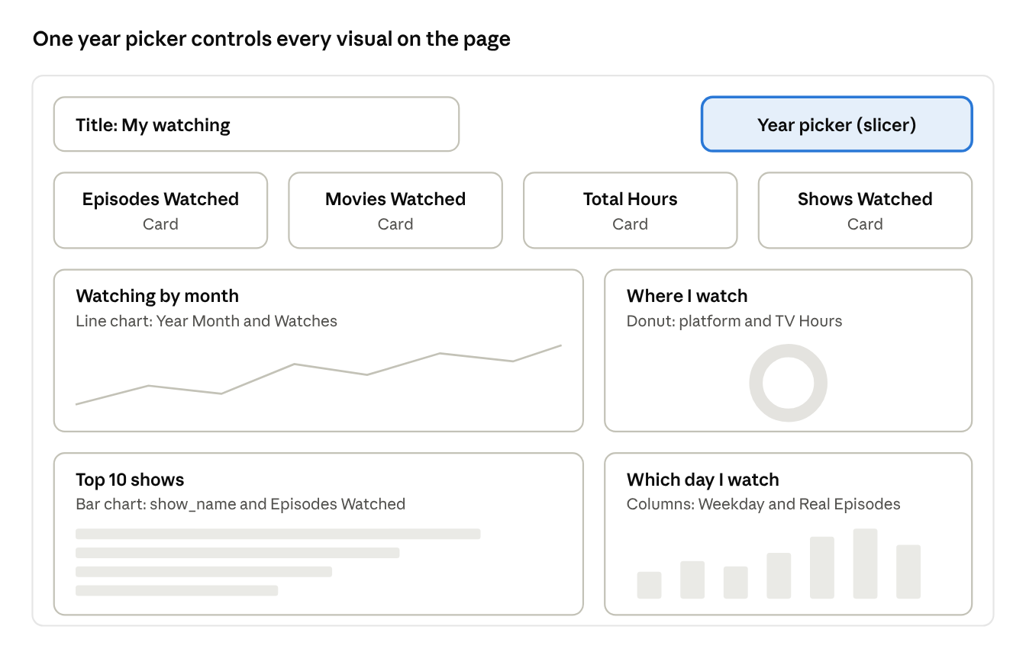
The finished page · a year picker, 4 cards, 4 charts
Build it top to bottom: title and year picker, then the four cards, then the four charts.
Tips before you start
- Hover over an icon in the Visualizations pane to see its name.
- To move a visual, drag its top edge. To resize it, drag a corner.
- To rename a visual's title: select it, click the paintbrush icon (Format visual), open General, then Title, and type a new title.
- Click an empty part of the page before adding each new visual. Otherwise you change the visual that is selected.
1. Page title
On the Insert tab, click Text box, type My watching, and make the text bigger.
2. Year picker
- Click the Slicer icon (a funnel over a small table).
- Drag Calendar → Year into Field.
- Optional: in Format visual, open Slicer settings, then Options, and change Style to Tile to get buttons instead of a list.
3. Four big numbers
- Click the Card icon (a box showing “123”).
- Drag the measure Episodes Watched into Fields.
- Repeat three more times for Movies Watched, Total Hours and Shows Watched, and line the four cards up in a row.
4. Watching by month (line chart)
- Click the Line chart icon.
- Drag Calendar → Year Month into X-axis, and the measure Watches into Y-axis.
- Title it Watching by month.
- If the months are out of order: click the … at the visual's top-right corner, choose Sort axis, then Year Month, then Sort ascending.
5. Top 10 shows (bar chart)
- Click the Clustered bar chart icon (horizontal bars).
- Drag Episodes → show_name into Y-axis, and Episodes Watched into X-axis.
- Keep only the top 10: open the Filters pane (between the page and the Visualizations pane). Under Filters on this visual, click show_name. Change Filter type to Top N, set Show items to Top and 10, drag Episodes Watched into By value, and click Apply filter.
- Title it Top 10 shows.
6. Which day you watch (column chart)
- Click the Clustered column chart icon (vertical bars).
- Drag Calendar → Weekday into X-axis, and Real Episodes into Y-axis.
- Sort Monday to Sunday: click …, then Sort axis, then Weekday, then Sort ascending.
- Title it Which day I watch.
7. Where you watch (donut chart)
- Click the Donut chart icon.
- Drag Episodes → platform into Legend, and TV Hours into Values.
- To hide shows without a platform: in the Filters pane, under platform, untick Not set.
- Title it Where I watch (hours).
Try it: click a year in the year picker. Every number and chart changes to that year. Click a bar, such as one show, and the other visuals highlight that show's share.

Part 7: Save, then refresh with new data (2 minutes each time)
Save once, and from then on updating the report takes about two minutes.
Save the report
- Click File, then Save as.
- Go to C:\WatchNext Data, name the file WatchNext report and click Save. Power BI saves it as WatchNext report.pbix.
Refresh with your latest watching
- In WatchNext, go to Settings, then Export for Power BI, and click Episodes, Shows and Movies again.
- In C:\WatchNext Data, delete the three old CSV files.
- Move the three new files from Downloads into C:\WatchNext Data, and rename them to the same short names as before: watchnext-episodes.csv, watchnext-shows.csv and watchnext-movies.csv.
- Open WatchNext report.pbix (double-click it).
- On the Home tab, click Refresh. Every chart updates.
- Press Ctrl+S to save.
The names must match exactly, because the code in Part 3 looks for those three file names.

If something goes wrong
What you see | What to do
DataSource.NotFound or “Could not find file” | The folder or file name doesn't match. Check that the folder is C:\WatchNext Data and the files are named exactly as in Part 2.
A column full of Error in the Power Query Editor | A file was opened and saved in Excel, which changes dates. Export fresh files from WatchNext and don't save them in Excel.
Japanese or other non-English titles look like strange symbols | Make sure the code has Encoding = 65001. It's already in the code above, so re-paste it.
A card shows a huge number for an ID | Power BI added up an ID column. Use the measures from Part 5 instead of dragging raw columns into cards.
Every bar or line is the same, or numbers look wrong | A wrong link in Model view. Make sure only the three links from Part 4 exist.
Months or weekdays in A–Z order | Redo the Sort by column step in Part 4, then Sort axis on the chart.
“Sign in” keeps popping up | Close it. You don't need an account for this guide.
A new show's platform shows a code like “max” | Add it to the PlatformNames line in that file's code (Part 3).

What the main columns mean
File | Column | Meaning
Episodes | show_name, season, episode | Which episode
Episodes | watched_date_local, watched_time_local | When you first watched it, in your own time zone
Episodes | watch_count | How many times you watched it (2 or more means rewatched)
Episodes | runtime_min, minutes_watched | Episode length, and length × times watched
Episodes | is_bulk_import | true for imported history ticked in one go
Episodes | show_status | Watching, Finished, Not started or Dropped
Episodes | genres | The show's genres, separated by “|”
Episodes | reaction, note | Your emoji reaction (as words) and your written note
Shows | in_library, on_watchlist | Whether you follow the show, or only have it on your Watchlist
Shows | rating, progress_pct | Your star rating, and how much of the show you've seen
Movies | status | watched or planned (on your Watchlist)
Movies | watched_date_local, rating | When you watched it, and your star rating
Ideas for a second page: a Movies page with a table of films by rating; your genres over the years; or a heatmap of the hours you watch by weekday.

